Content which have to be written

1. A 4 to 5 lines content on our industries for example (the content that is written is demo content)

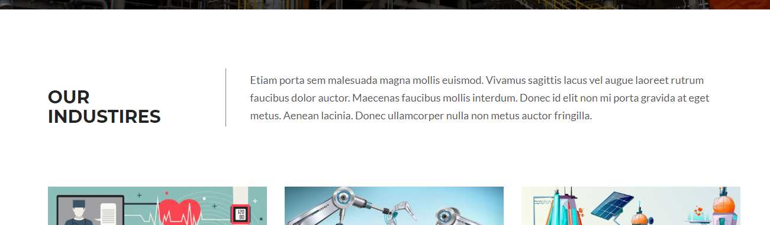

1. Some content on “OUR RECENT PROJECTS” and their pictures
2. Some pictures of equipment’s
3. Some content on financial consulting and engr. Solutions for example



(content of software solution is already mention In the seido live website wo don’t need to write software solution, if you want to update the content of software solution so its up to you )

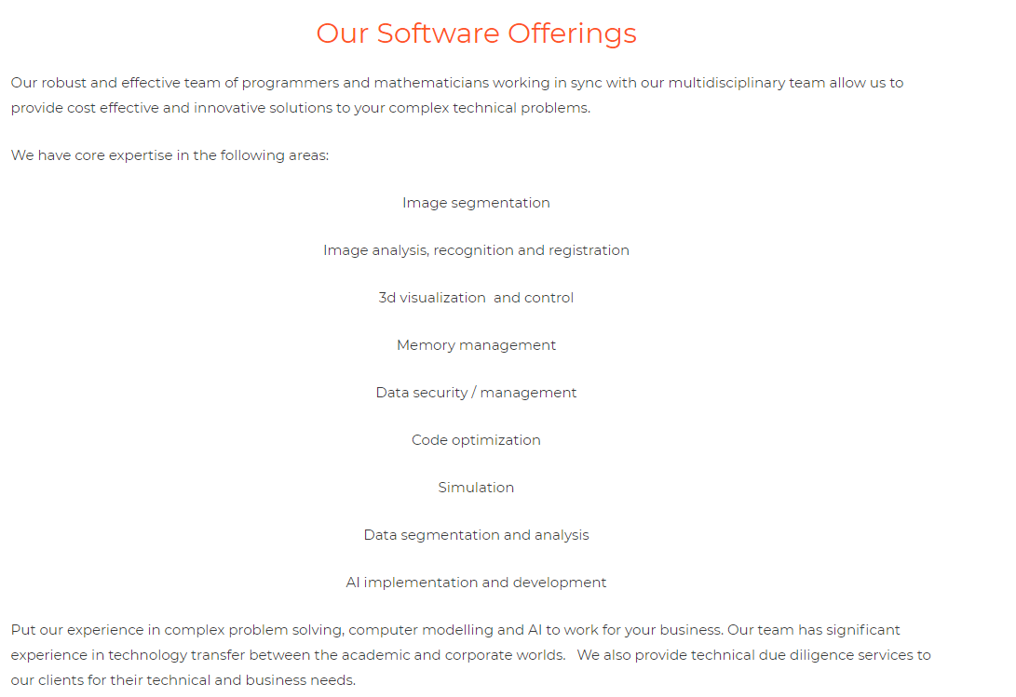

Like this in live website, kuch is trah ka content financial or engr. Solutions ka ho

1. Any testimonial of your previous clients, if you want to add on your website otherwise no need
2. Any recent news or blogs if you want to add otherwise no need of it.